1. In MATLAB, input the following matrix，and use this matrix to answer the following questions :



a. Construct a 4 × 3 matrix **B**，its elements is the second column through 4-th column of A.

b. Construct a 3 × 4 matrix **C**，its elements is the second row through 4-th row of A.

c. Construct a 2 × 3 matrix **D**，its elements is the first two rows and last three columns of A.

1. In MATLAB, find the length and absolute value of the following vectors:

a. **x** = [2, 4, 7]

b. **y** = [2, –4, 7, -6]

1. Construct following matrix A and let B=ln(A’):

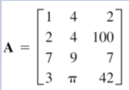

Use MATLAB to find the following:

1. Construct a matrix **C**，it is the transpose of A.
2. Construct a matrix **D,** deleting **2-nd row of A.**
3. Add a column with values 1 to the 2-nd column of D.
4. Extracting 1st and 3th column of A and put it into the matrix E.
5. Construct vector **x,** its elements is the only second row of **B**.
6. Calculate the sum of all the elements of **x.**
7. Pointwise multiplication of the 2-nd row of A and 3-th column of B.
8. Pointwise multiplication of the 1st row of A and 3-th column of B.
9. Find the maximum, minimum and summation values of the resulting vector in h.
10. The following table shows the cost of a product and the output of the four seasons for each business year. Using MATLAB to find (*a*) the cost of materials, labor, and transportation for each season. (b) the total cost of materials, labor, and transportation for each year. And (*c*) total costs of each season.

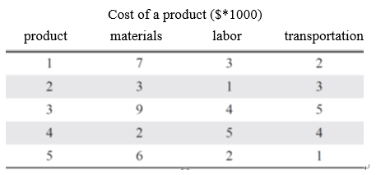

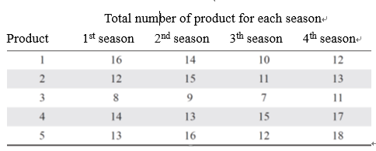

1. Cables of length *Lc* support a beam column of length *Lb* that remains level when the end of the beam column hangs an object with weight W. According to the law of statics, the tension T of this cable can be calculated



Where D is the distance from the connection cable to the beam column. Refer to the following figure

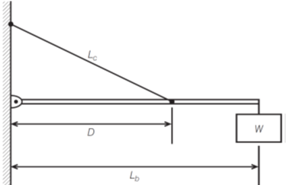

1. Given that *W* = 400 N，*Lb* = 3 m, and *Lc* = 5 m，use pointwise operation and ‘min’ function to find the distance D which lead to the minimum tension T.
2. Plot the relationship between the tension T and the distance D.
3. Aircraft **A** flew east at a rate of 320 mi/hr and aircraft **B** flew south at a rate of 160 mi/hr. The position of the aircraft at 1 pm is shown in the following Figure.

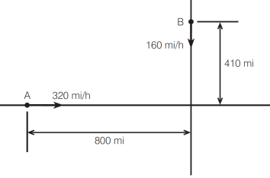

1. Find the distance D between two airplanes as a function of time. D is plotted against time until D reaches its minimum value.
2. Given the following matrices



Use the MATLAB to verify the following properties:

1. The association property:



1. The distribution property :

